

Risk Management Plan
Q-0026
Revision A

Revision History
Rev | Status | Date | Author | CO # | Description
A | Draft | 10/29/04  11/28/05  4/7/10 | C. Burr  S. Belanich  S. Belanich | TBD | Initial draft  Final draft

Training
Role | New | Trained in previous rev.
Quality Manager | Read the document.  Consult with the Quality Manager as needed. | Not applicable in Rev A
Chief Medical Officer |  | Not applicable in Rev A
Project Leader |  | Not applicable in Rev A

Purpose
The Risk Management Plan documents the risk management strategy for each product. It lists the hazards, hazard mitigation strategy, references to the Requirements Traceability database, the residual risk evaluation, and the overall residual risk assessment.

Scope
A Risk Management Plan is prepared for every MedCommons medical device product, and other products as deemed appropriate by MedCommons management. The Risk Management Plan is updated, reviewed, and approved before each release of the product other than maintenance releases that include only non-safety-related defect correction.

Responsibilities

Chief Medical Officer
The Chief Medical Officer is responsible for benefit/risk assessment based on his knowledge of the medical application.

Quality Manager
The Quality Manager is responsible for ensuring the integrity of information, particularly the linkage between the Risk Management Plan and the Requirements Traceability database. The Quality Manager ensures required testing is completed per the Requirements Traceability database and the Verification and Validation Plan.

Project Leader
The Project Leader is responsible for technical accuracy of information in the Risk Management Plan and the Requirements Traceability database. The Project Leader oversees the implementation of safety-related requirements and specifications and the relevant verification and validation activities.

Records created
Record type | Form or template | Where filed
Risk Management Plan | Q-0026 Form A | Design History File

Related Documents
- Q-0021 Design and Development
- Q-0008 Software Development
- Q-0016 Product Corrective and Preventive Action
- Q-0032 Design Verification and Validation

Definitions
Harm: physical injury or damage to the health of people, or damage to property or the environment.
Hazard: a potential source of harm or mechanism that causes or contributes to harm
Likelihood: the probability of occurrence of harm (not of the hazard)
Risk: an assessment of the combination of the severity of harm and its likelihood.
Acceptable risk: A risk which does not require further mitigation
ALARP (As-Low-As Reasonably Practical) risk: A risk that should be mitigated if possible with reasonable expense, effort, and time. If no reasonable mitigation is available, management may approve the acceptance of an ALARP risk in the released product.
Unacceptable risk: A risk that is not acceptable in the released product.
Residual risk: Risk remaining after mitigation requirements have been implemented and verified.
Overall residual risk: The combination of all residual risks. The overall residual risk is compared to the benefits of the product when making the decision to release a product.

Process Flow
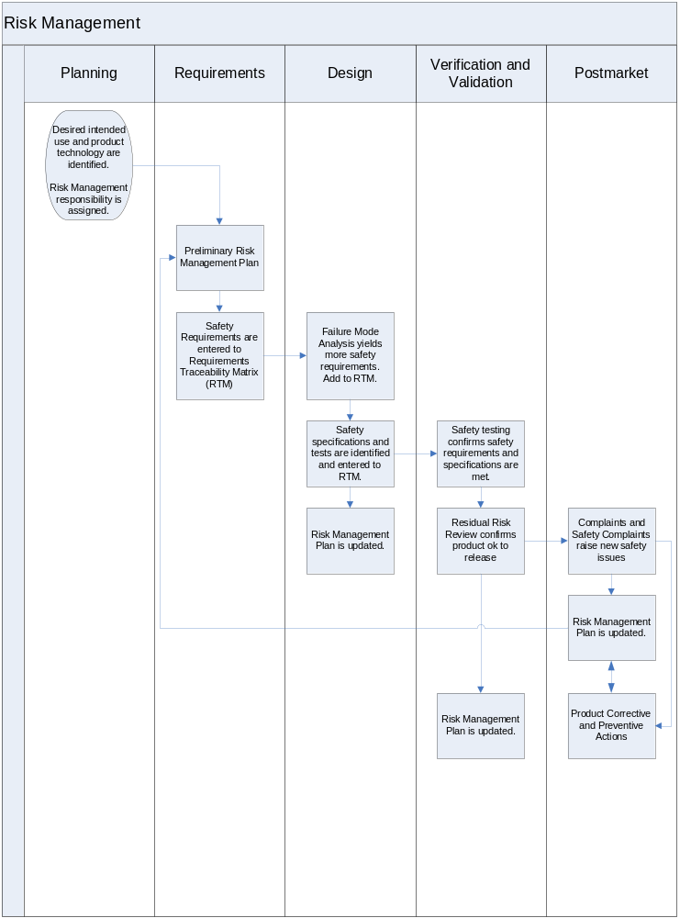

Procedure
Step | Detailed Description
Design Planning
Desired intended use and product technology are identified.  Risk Management responsibility is assigned. | In Design Planning and Design Input, the intended use, product technologies, high level design, and similar products are known. Hazards are identified by reviewing:  - Questions in ISO 14971 Appendix A  - Essential Requirements in the Medical Device Directive, Appendix 1  - Relevant standards and regulations  - Hazards previously identified for this product (if the project modifies an existing product)  - Medical Device Reports for products with similar classification (MAUDE) http://www.accessdata.fda.gov/scripts/cdrh/cfdocs/cfMAUDE/search.CFM  - Other sources, e.g., medical literature, advisors  Preliminary risk assessments can be performed to determine if risk mitigation is required. Relevant safety standards or common risk mitigation methods can be identified.
Design Input
Preliminary Risk Management Plan | Enter hazard and preliminary risk assessments into the Risk Management Plan. (See Risk Assessment section on page 7.) Enter planned safety standards or mitigation strategies.  The purpose of risk estimation is to decide if risk reduction is appropriate. If it is known in advance that a risk reduction strategy will be used, one does not need to estimate the risk in absence of the risk reduction strategy. Situations in which a risk reduction strategy may be assumed include:  - A standard or regulation specifies a risk reduction strategy or a requirement that necessitates a risk reduction strategy.  - An existing product already employs a risk reduction strategy  - Common engineering practice or customer expectations suggest a risk reduction strategy.  Based on risk assessments, the need for further risk mitigation is determined. Risk mitigation methods are identified and selected.  Release criteria for total residual risk are identified.
Safety Requirement are entered to Requirements Traceability Matrix (RTM) | Risk mitigation methods become product requirements to be entered in the Requirements Traceability database. Identify the requirements as Safety Requirements.
Design Output
Failure Mode Analysis yields more safety requirements. Add to RTM. | Knowledge of the detailed product design allows failure mode analysis to identify additional hazards or to provide additional information about known hazards. The hazards are entered to the Risk Management Plan and the risks are assessed. Associated mitigation methods are added to the RTM. Identify the requirements as Safety Requirements,
Safety specifications and tests are identified and entered to RTM. | For each Safety Requirement, enter associated specifications and tests to the RTM.
Risk Management Plan is updated. | Prior to each phase checkpoint, the Risk Management Team reviews and updates the Risk Management Plan.
Design Verification / Validation
Safety testing confirms safety requirements and specifications are met. | The result of testing are tracked in the RTM. Test failures may suggest hazards to be evaluated.  If there are test failures that cannot be resolved, the mitigation method must be reviewed. Another mitigation method may be needed.
Residual risk confirms product OK to release. | The product release decision includes a comparison of total residual risk to the release criteria established during Design Input. The decision that total residual risk is acceptable is reviewed and approved by the approvers of the Release checkpoint design review.  This information is reviewed:  - Updated Risk Management Report. Is the residual risk of the total system acceptable or as low as reasonably practical? In other words, is the product safe, free of unacceptable risk?  - Requirements Traceability Matrix. Have all safety requirements and specifications been verified and validated satisfactorily?
Risk Management Plan is updated. | Prior to each phase checkpoint, the Risk Management Team reviews and updates the Risk Management Plan.
Postmarket
Complaints and Safety Complaints raise new safety issues. | Safety complaints, MDR activity for similar products, and information from other sources suggest hazards to be evaluated. Typically these hazards are much more detailed and specific, than those identified in earlier phases.
Risk Management Plan is updated. | If a new hazard is identified, or if risk assessment or mitigation strategy for a known hazard has changed, the Risk Management Plan is updated.
Product Corrective and Preventive Actions | See Q0036, Product Correct and Preventive Actions. Product CAPA provides the procedure for identifying root causes and associated actions to prevent occurrence or recurrence of product problems. Product CAPA Action plans may include mitigations strategies to be included in the Risk Management Plan.  For safety issues that affect installed products, Q0031, Safety Notifications, Field Corrections, and Recalls, provides the procedure for determining when user or agency notification or a field correction (recall) is appropriate.

Risk Assessment
Risk assessment determines if risk is acceptable or if action is needed to reduce risk. The risk level is determined by assessing likelihood and severity of harm and then combining the two values using the table below.

Risk Level
U = Unacceptable: Bring down risk
R = Reduce the risk As Low As Reasonably Practical (ALARP)
A = Acceptable: No further safety measures required
Severity
Major Death or major, long-term serious disease or injury
Moderate Disease or injury requiring professional health care
Minor Disease or injury not requiring professional health care
Negligible Little or no potential of disease or injury

Likelihood
Frequent Likely to occur frequently in the life of a system
Probable Likely to occur several times in life of a system
Occasional Likely to occur sometime in life of a system
Remote Unlikely but possible to occur in life of a system
Negligible Extremely unlikely to occur in life of a system

Severity  Likelihood | Negligible | Minor | Moderate | Major
Frequent | A | R | U | U
Probable | A | R | R | U
Occasional | A | R | R | U
Remote | A | A | R | R
Negligible | A | A | A | A

In Design Output, Design Verification / Validation, and Postmarket, hazards identified in testing and actual use are often specific forms of more general hazards identified in Phases 1 and 2. The risk evaluator should use the risk estimation approach described above, and then compare results to those of the related general hazard.
- Are risk estimates consistent from the general hazard to the specific hazard?
- Does the test failure or safety complaint provide information that changes the risk estimation of the general hazard? Is it more or less severe? More or less likely?
- Should the Risk Management Report be updated?

Risk Control
Risk reduction strategies should be chosen in this order of preference:
- Design to eliminate or prevent the hazard from occurring
- Provide protective measures to reduce risk if the hazard occurs
- Inform the user through labeling of the hazard and ways to avoid the risk

Risk reduction strategies are mapped to product requirements and specifications. Essential aspects of a risk reduction strategy that addresses a significant risk are deemed critical safety requirements or specifications.

Requirements and specifications are entered into the Requirements Traceability Matrix. Safety-related requirements and specifications must be satisfactorily verified or validated before product release. Critical safety requirements implemented in software must be validated in each iteration of regression testing.

Risk Management Report
The Risk Management Report is the combination of records of hazard identification, risk estimation, and risk control (including the Requirements Traceability Matrix). The Product Risk Coordinator prepares and maintains the Risk Management Report. The Quality Manager and Engineering Manager review and approve updated Risk Management Reports prior to Phase Exits or other times an updated Risk Management Report is entered into the Design History File or the Device Master Record.

